Demo video link: https://drive.google.com/file/d/11x-loyx5KwXJZ2f5izKJvYHt-pfMXo3r/view?usp=sharing
GitHub link: https://github.com/JialongYin/lab4.git
Team member: Jialong Yin

Conclusion of visualizations: from the figures below, we can tell that all the vehicles can achieve the maximum CO2 emission after some time stamp. Vehicle 3 is the most energy-efficient and environment-friend. And vehicle 0 is the worst.

Vehicle 0 max CO2 emission vs. Time stamp
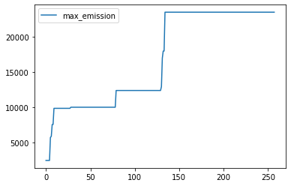

Vehicle 1 max CO2 emission vs. Time stamp
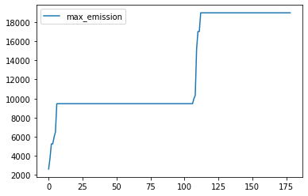

Vehicle 2 max CO2 emission vs. Time stamp
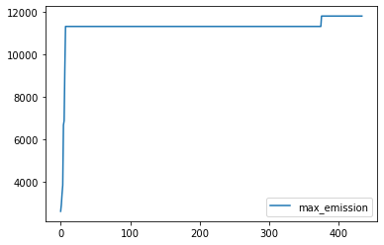

Vehicle 3 max CO2 emission vs. Time stamp
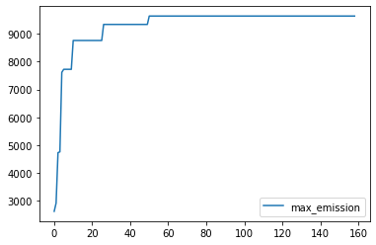

Vehicle 4 max CO2 emission vs. Time stamp
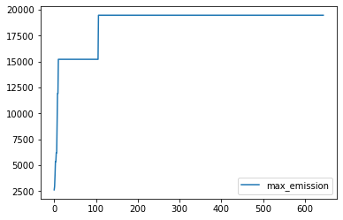

Max CO2 emission vs. Vehicle No.
